**MZUMBE UNIVERSITY**



**FACULTY OF SCIENCE AND TECHNOLOGY**

COURSE : BSC ICTM -2

NAME OF LECTURER : MR.RUTATOLA

NAME OF SUBJECT : WEB DEVELOPMENT

CODE OF SUBJECT : CSS 221

TASK : INDIVIDUAL ASSIGNMENT

STUDENT NAME : SIDDY IDDY SIDDY

REGISTRATION NUMBER : 14320011/T.20

DATE OF SUBMISSION : 25/05/2022

TASK;CREATE FROM SCRATCH, A SIMPLE SINGLE-PAGE WEBSITE FOR ANY ORGANIZATION OR PERSON OF YOUR CHOICE.

**SOURCE CODE**

.**PHP AND HTML SOURCE CODE**

<!DOCTYPE html>

<html>

<meta charset="UTF-8">

<meta name="viewport" content="width=device-width, initial-scale=1">

<style>

body{

background-color: lightpink;

width: 100%;

height: 700PX;

font-size: 15px;

}

h2 {

background-color: lightpink;

text-align: center;

}

div {

background-color: lightpink;

text-decoration-color: white;

}

p {

}

H1{

color: maroon;

margin-left: 10PX;

}

.topnav {

overflow: hidden;

background-color: pink;

}

.topnav a {

float: left;

color: #f2f2f2;

text-align: center;

padding: 14px 16px;

text-decoration: none;

font-size: 17px;

}

.topnav a:hover {

background-color: #ddd;

color: black;

}

.topnav a.active {

background-color: #4CAF50;

color: white;

}

input[type=text], select, textarea {

width: 100%;

padding: 12px;

border: 1px solid #ccc;

border-radius: 4px;

box-sizing: border-box;

margin-top: 6px;

margin-bottom: 16px;

resize: vertical;

}

input[type=submit] {

background-color: #4CAF50;

color: white;

padding: 12px 20px;

border: none;

border-radius: 4px;

cursor: pointer;

}

input[type=submit]:hover {

background-color: #45a049;

}

.container {

border-radius: 5px;

background-color: #f2f2f2;

padding: 20px;

}

.form-container{

min-height: 100vh;

display: flex;

align-items: center;

justify-content: center;

padding:20px;

padding-bottom: 60px;

background: #eee;

}

.form-container form{

padding:20px;

border-radius: 5px;

box-shadow: 0 5px 10px rgba(0,0,0,.1);

background: #fff;

text-align: center;

width: 500px;

}

</style>

<body>

<h1>CREATIVE DESIGN</h1>

<!-- Navigation -->

<div class="topnav">

<a class="active" href="#home">Home</a>

<a href="#About">About Us</a>

<a href="#Features">Features</a>

<a href="#Testmonial">Testmonial</a>

<a href="#contact">contact</a>

</div>

<!--slide show-->

<section>

<img class="mySlides" src="Anel_Curve6.png" style="width:33%;height:700px;margin-bottom: 50px; border-radius: 5px;">

<img class="mySlides" src="curved_over.png" style="width:33%;height:700px;margin-bottom: 50px; border-radius: 5px">

<img class="mySlides" src="making_over.png" style="width:33%;height:700px;margin-bottom: 50px; border-radius: 5px">

</section>

<!--About description-->

<div class="About">

<h2>About Us</h2>

<P style="font-size: 30px;">

"Fashion is not something that exists in dresses only.Fashion is in the sky, in the street,fashion has to do with ideas,the way to live,what is happening".-Coco Chanel once said.

<br>

CREATIVE DESIGN is Tanzanian Fashion designing company based in East Africa.From an early age we were interested in the arts and manual tasks and our favorite activity was always in competing with greater designer in world by providing most beautiful design to people.For us few things are more pleasurable than seeing an idea become material and enter people's lives,creating bonds between those who create and those who wear it.

<br>

In addition to the creative consultancy work,the development of the collection-technical drawings and production specifications-can be done on the basis of research raised by the creative consultancy or from a briefing or research that the brand has previously built.

</P>

</div>

<!--Features description-->

<div class="Features">

<h2>FEATURES</h2>

<P>

<h3 style="font-size:20px">OUR DESIGNS</h3>

<div>

<h4 >women's design</h4>

<p style="text-align:center;">

your one-stop destination for discovering ground breaking talent,exclusive products and our unique perspective on the wold of women fashion

<br>

this is our collections

<img class="mySlides" src="download (1).jpeg" style="width:33%;height:700px;margin-bottom: 50px; border-radius: 5px;">

<img class="mySlides" src="download (2).jpeg" style="width:33%;height:700px;margin-bottom: 50px; border-radius: 5px">

<img class="mySlides" src="download (3).jpeg" style="width:33%;height:700px;margin-bottom: 50px; border-radius: 5px">

</p>

</div>

<div>

<h4>men's design</h4>

<p style="text-align:center;">

your one-stop destination for discovering ground breaking talent,exclusive products and our unique perspective on the wold of men fashion

<br>

this is our collections

<img class="mySlides" src="download (4).jpeg" style="width:33%;height:700px;margin-bottom: 50px; border-radius: 5px;">

<img class="mySlides" src="images (37).jpeg" style="width:33%;height:700px;margin-bottom: 50px; border-radius: 5px">

<img class="mySlides" src="images (38).jpeg" style="width:33%;height:700px;margin-bottom: 50px; border-radius: 5px">

</p>

</div>

<div>

<h4 >children's design</h4>

<p text-align:center;">

your one-stop destination for discovering ground breaking talent,exclusive products and our unique perspective on the wold of children fashion

<br>

this is our collections

<img class="mySlides" src="download (5).jpeg" style="width:33%;height:700px;margin-bottom: 50px; border-radius: 5px;">

<img class="mySlides" src="images (43).jpeg" style="width:33%;height:700px;margin-bottom: 50px; border-radius: 5px">

<img class="mySlides" src="images (41).jpeg" style="width:33%;height:700px;margin-bottom: 50px; border-radius: 5px">

</p>

</div>

</P>

</div>

<!--Testmonial description-->

<div class="Testmonial">

<h2>WHAT OUR CLIENT SAYS</h2>

<P >

<i>"your collection of design has been very good in terms of both results and support to us"</i>

<br>

.NDELECHE NDELECHE

<br>

<i>"ONLY ONE PLACE WITH WHAT I WANT TO WEAR...OOPS LOVE U GUYS"</i>

<br>

.OMARY OMARY

</p>

</div>

<!--Contact description-->

<h2>Contact Form</h2>

<div class="container">

<form action="#" method="post" >

<label for="fname">Full Name</label>

<input type="text" id="fname" name="fullname" placeholder="Your name..">

<label for="email">Email</label>

<input type="text" id="email" name="email" placeholder="Your email..">

<label for="address">Address</label>

<input type="text" id="address" name="address" placeholder="Your address...">

<label for="pNumber">Phonenumber</label>

<input type="text" id="email" name="phonenumber" placeholder="Your phone number..">

<label for="subject">Subject</label>

<textarea id="subject" name="subject" placeholder="Write something.." style="height:200px"></textarea>

<input type="submit" value="Submit" name="siddy">

</form>

</div>

<!--footer -->

<div class="footer" >

siddy01siddy@gmail.com

<br>

0746054223

<br>

mzumbe,Tanzania.

<br>

<?php

if (isset($_POST['siddy'])) {

$fullname=$_POST['fullname'];

$email=$_POST['email'];

$address=$_POST['address'];

$phonenumber=$_POST['phonenumber'];

$subject=$_POST['subject'];

$connect=mysqli_connect("localhost","root","","siddy");

$sql="insert into user(fullname,email,address,phonenumber,subject) values ('$fullname','$email','$address','$phonenumber','$subject')";

$query=mysqli_query($connect,$sql);

if($query) {

echo "DEAR $fullname THANK YOU FOR THE FEEDBACK";

}

else{

die(mysql_error($connect));

}

}

?>

</body>

</html>

**SCREENSHOOT**

**1.webpage**

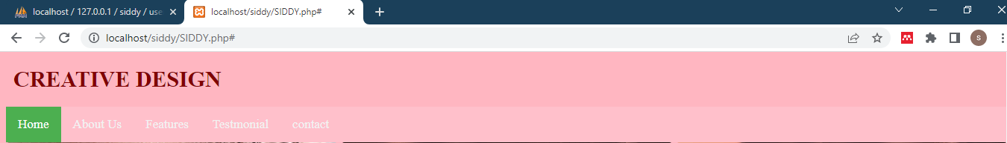

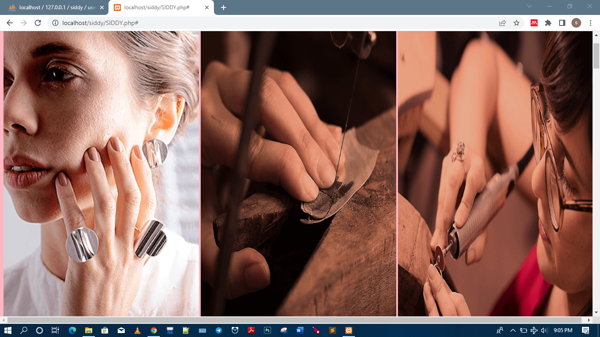

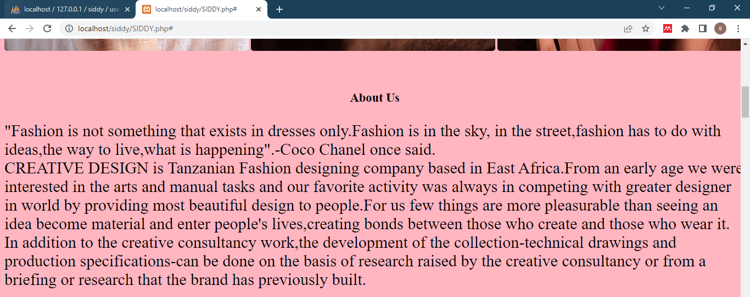

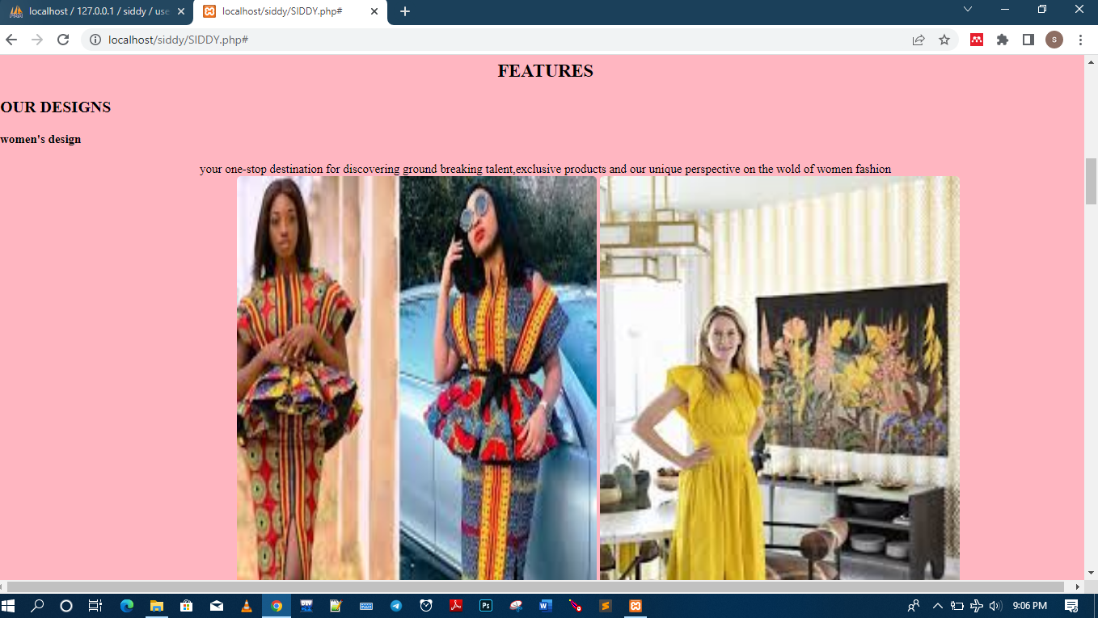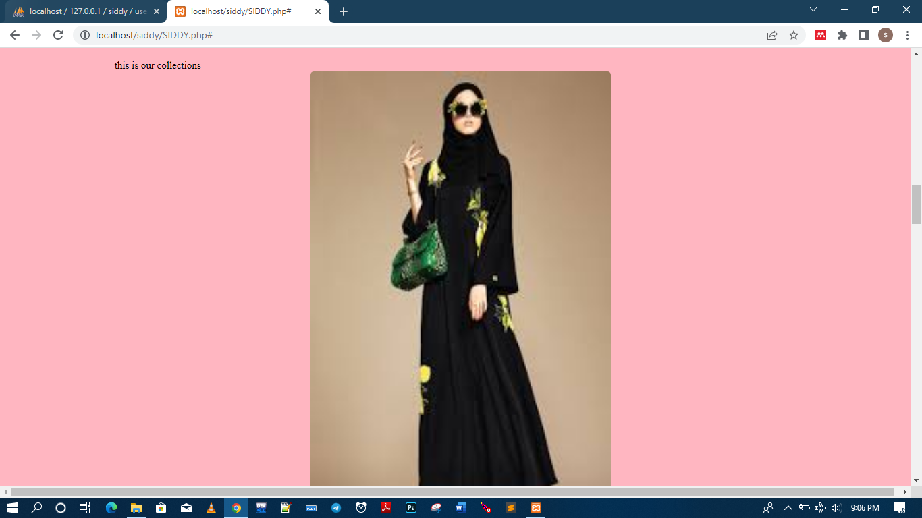

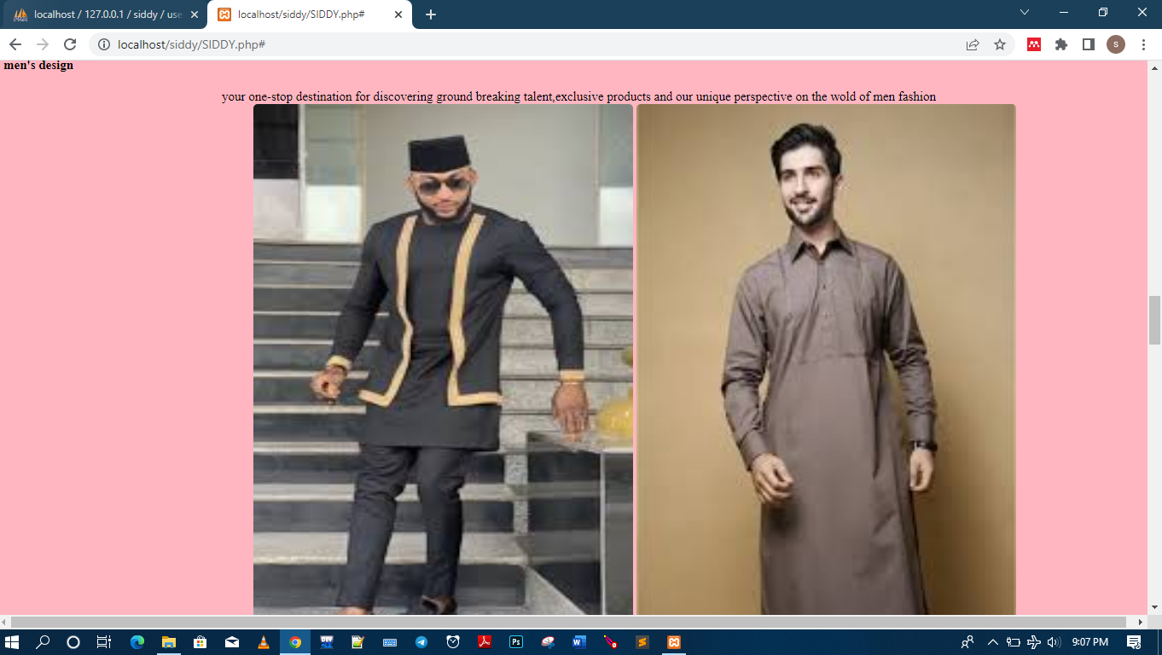

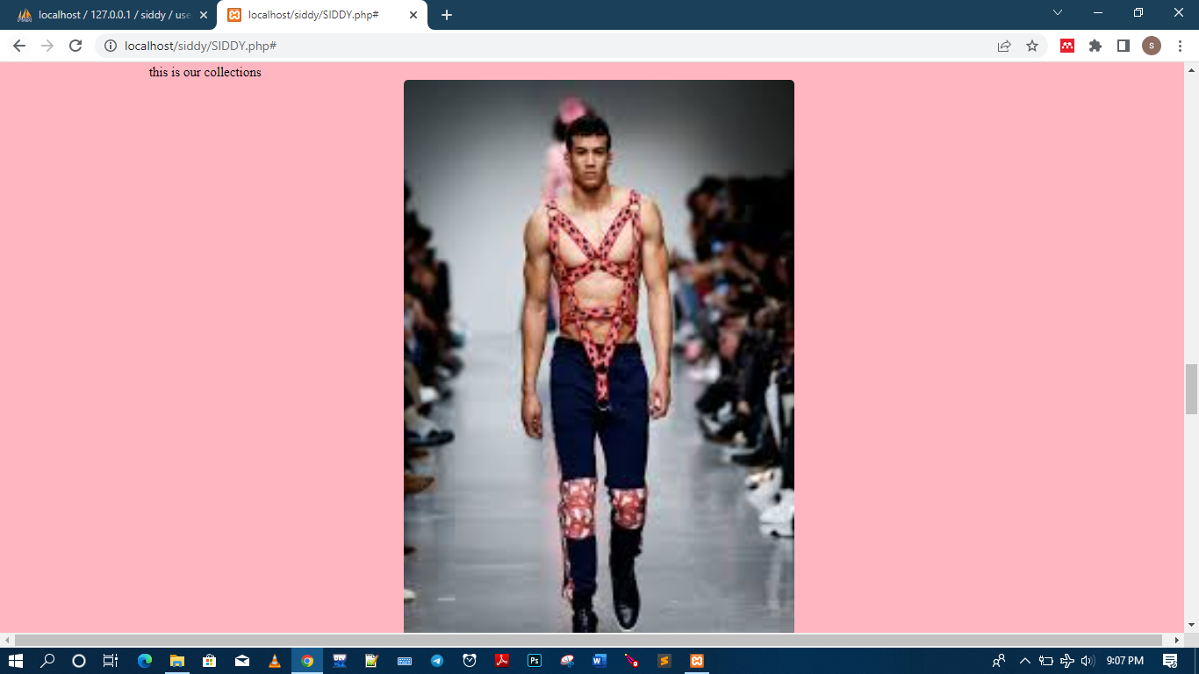

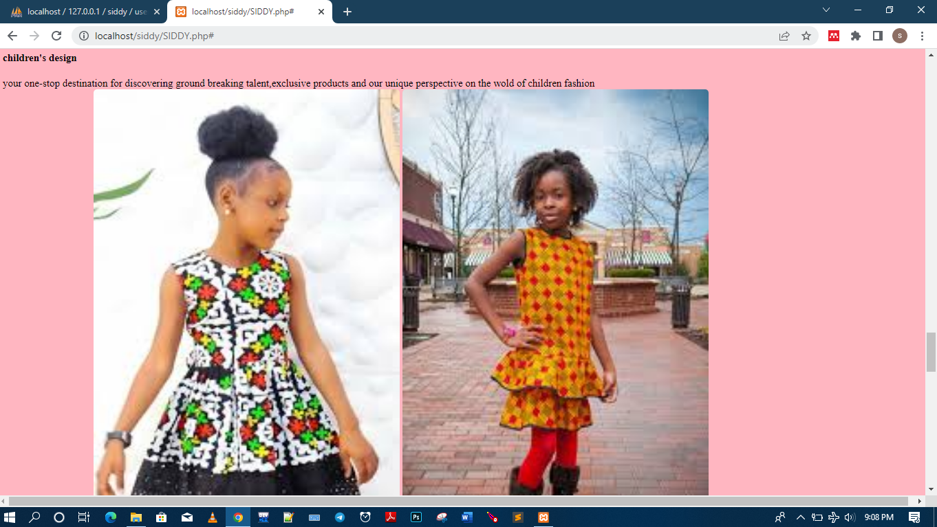

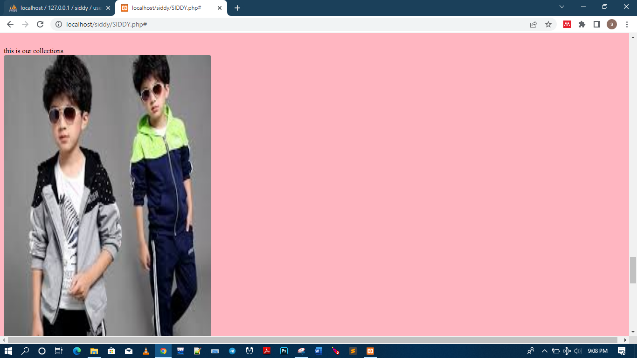

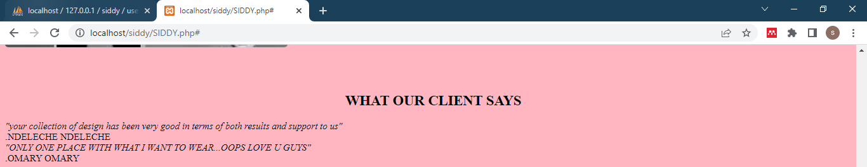

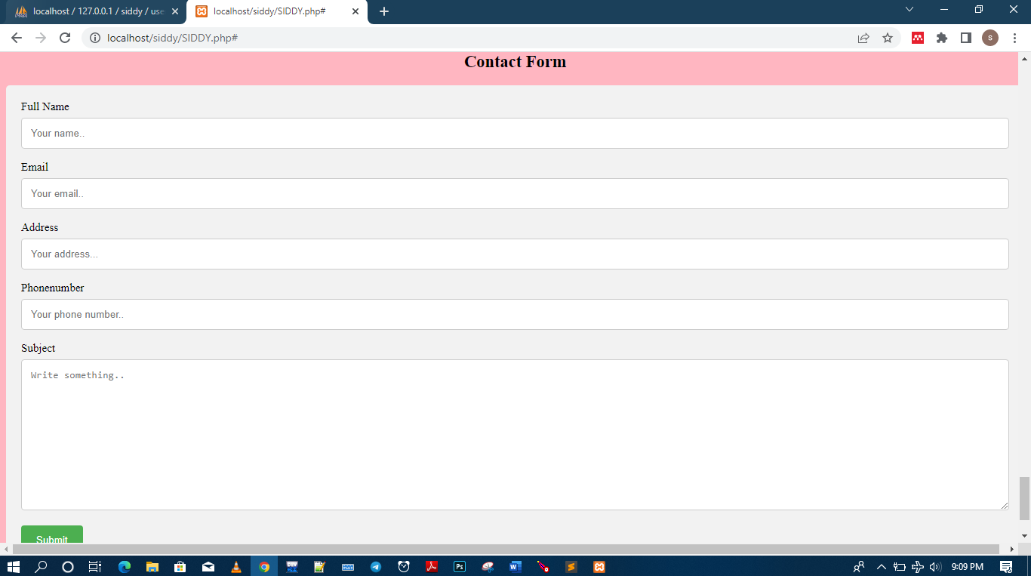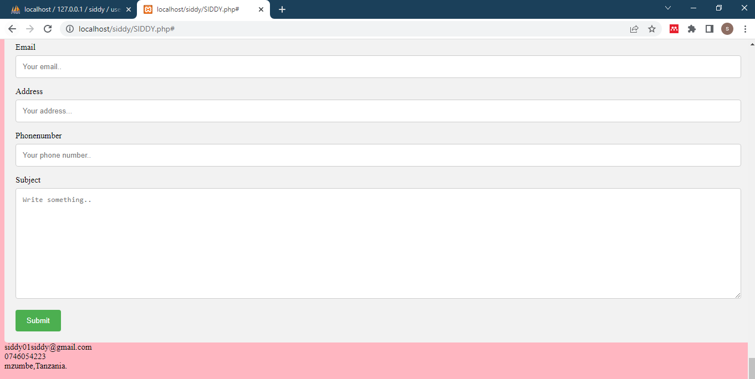

2.**DATABASES SCREENSHOOT**

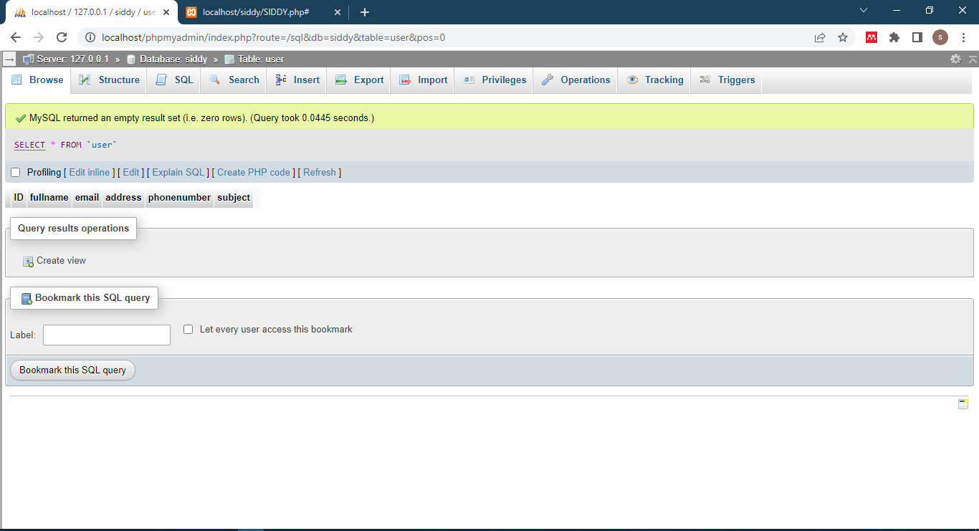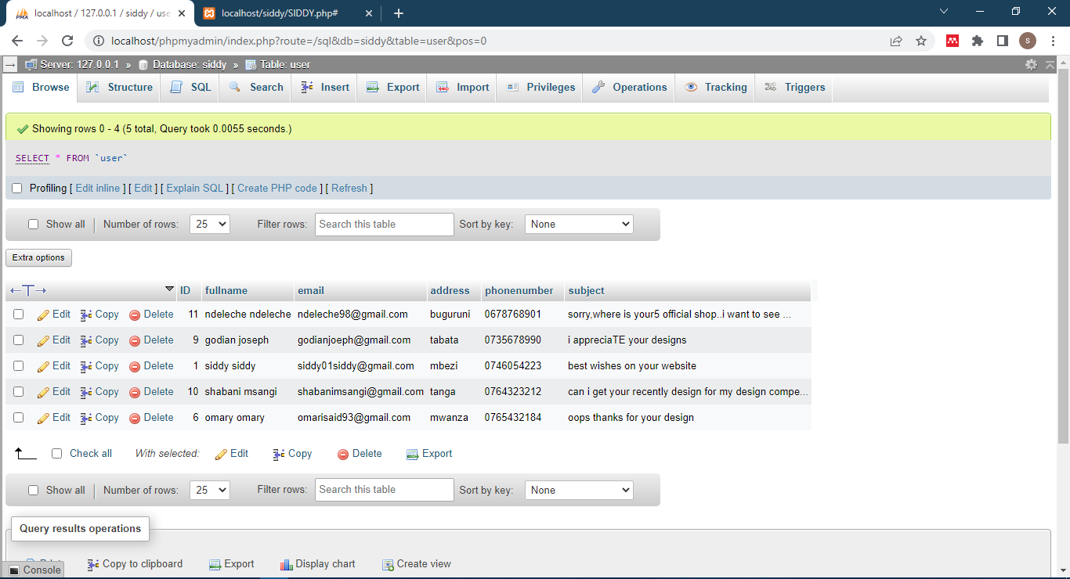

**REFERENCES**

Retrieved from<www.w3schools.com>